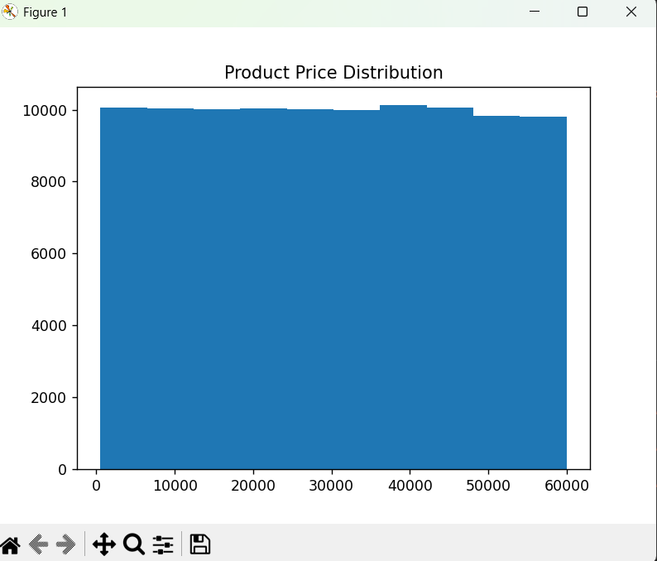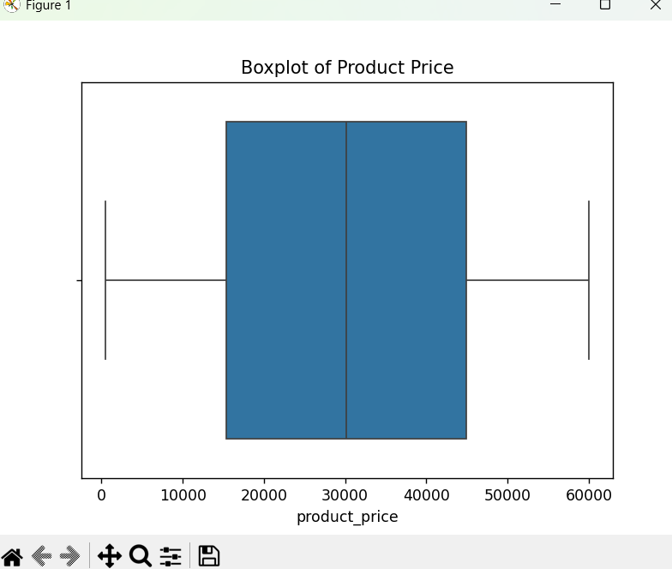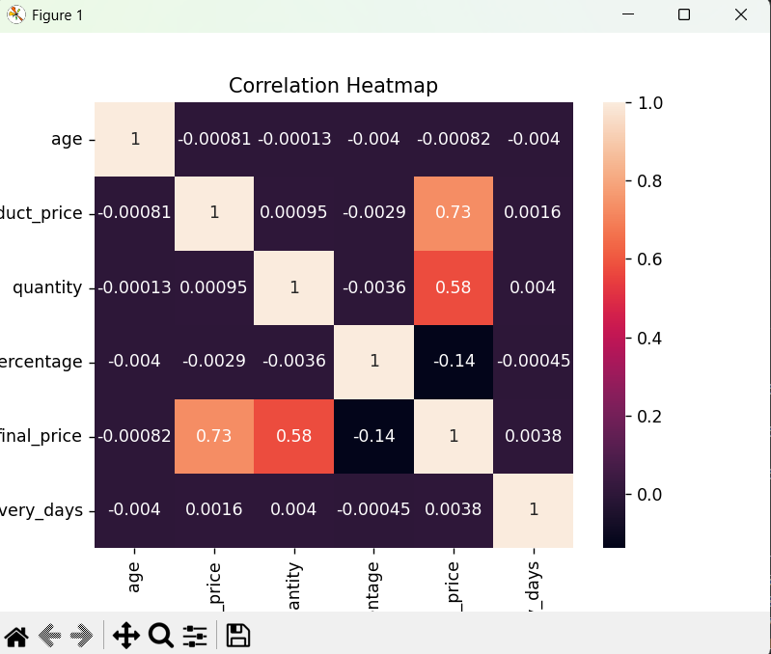Exploratory Data Analysis of Large-Scale Retail Transaction Data

Introduction
Exploratory Data Analysis (EDA) is a statistical approach used to analyze, summarize, and visualize datasets before applying machine learning models.
In this project, we performed EDA on a large retail transaction dataset containing 100,000 records and multiple variables.

Objectives
The main objectives of this project are:
- To perform univariate, bivariate, and multivariate analysis
- To detect outliers
- To analyze correlation between variables
- To understand data distribution using statistical methods

Dataset Overview
- Total Rows: 100,000
- Total Columns: 18
- Data Types: Numerical, Categorical, Date

Univariate Analysis
Univariate analysis focuses on analyzing one variable at a time.
- The distribution of product_price shows positive skewness
- Most values are concentrated in the lower and medium price range
- A few high-value transactions are present

Boxplot Analysis
The boxplot of product_price shows:
- The median value lies near the center
- The data is moderately spread
- Some variation exists in product prices
- No extreme abnormal outliers are observed

Correlation Analysis (Heatmap)
The heatmap shows relationships between numerical variables:
- Strong positive correlation between:
  - product_price and final_price
  - quantity and final_price
- Negative correlation between:
  - discount_percentage and final_price
- Weak correlation between:
  - age and spending

Outlier Detection
- Outliers are present in product_price and final_price
- These outliers represent high-value transactions
- They are not removed as they are important for business analysis

Key Insights
- Revenue is mainly driven by high-value transactions
- Moderate discounts increase customer spending
- Product price directly impacts final price
- Delivery time has minimal impact on sales

Tools Used
- Python
- Pandas
- NumPy
- Matplotlib
- Seaborn

Conclusion
This project successfully applied Exploratory Data Analysis techniques to understand the dataset.
The analysis helped identify patterns, relationships, and important business insights.
This provides a strong foundation for future predictive modeling.

Submission Details
Name: Aruna_______
Date: 24 March 2026
Course: Data Science_____

